**D.El.Ed. (2 years)**

**Program outcomes**

1. Prepare students for elementary or primary schools

2. Application of appropriate approaches, strategies and methods to achieve instructional objectives till elementary level.

3. Display basic understanding of school subjects

4. Foster critical thinking among learners

4. Crack competitive exams such as Centre Teacher Eligibility Test and State teacher eligibility Test

5. being placed in schools as PRT

**D.El.Ed. 1ST Year**

**Course Outcomes**

**Childhood and the Development of Children**

1. To review general conceptions about child and childhood (specifically with reference to the Indian social context); develop a sensitive and critical understanding of the different social/educational/cultural realities at the core of the exploration into childhood.
2. To develop an understanding of different aspects of a child’s physical, motor, social and emotional development.
3. To understand the developmental process of children with diverse abilities in social, cultural and political context.
4.  To encourage interaction with children, and training in methods of child study.

**Contemporary Indian Society**

1. To be familiar with the interdisciplinary analysis of concepts, ideas and concerns to gain an understanding of the socio- political and economic dimensions of Indian society and appreciating its diversity.
2. To develop an understanding of the trends, issues, and challenges facing contemporary Indian society.
3. To arrive at a critical understanding of the achievements and persisting problems of the contemporary Indian context and the challenges facing it.

**Education, Society, Curriculum and Learners**

1. To understand and explore the meaning, aims, purposes of education.
2. To develop understanding of philosophical, sociological and historical dimensions of education.
3. To identify and question one’s own long-established presumptions on knowledge, learner, teacher, and education, and develop a more informed, meaningful understanding of them.
4. To expose students to divergent educational thoughts, perspectives and practices, which will help them in creating secure, egalitarian and pedagogically sound learning situations.

**Pedagogy and ICT across the Curriculum**

1. To engage student-teachers with key issues of organizing schools and learning environments and of visualizing and selecting appropriate pedagogic approaches.
2. To enable them to link their understanding of children, of their social contexts and of curricular knowledge, to practical steps in organizing, motivating and assessing learning.
3. To enables them to focus on generic aspects of pedagogy that cut across various school subjects.
4. To widen their awareness of pedagogic possibilities, and to enrich their 'pedagogic imagination', so that student-teachers can think beyond standard approaches, and try to fit their pedagogic approaches with their aims of teaching and learning, while creating nonthreatening learning environments.
5. To enable them to understand the meaning and scope of ICT and its applications in teaching learning.
6. To make them Understand the computer components and software and hardware approach in education. They are able to learn and to use the e-learning in the process of learning.

**Pedagogy of Environmental Study**

1. To help student-teachers understand the scope of EVS and examine different perspectives of curriculum organization.
2. To facilitate student-teachers to probe children’s ideas in science and social science.
3. To prepare student-teachers to plan for and carry out classroom transaction in the light of various theoretical viewpoints of learning and children’s ideas.
4. To prepare student-teachers to assess children’s learning using different modes.

**Learning Mother Tongue and other Languages: In and outside the school**

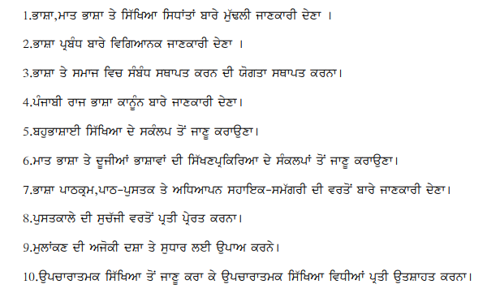

**Pedagogy of Mathematics**

1. To enable student-teachers to develop deeper insights into the content areas of mathematics at the primary level
2. To make student-teachers aware of factors that impact on the process of acquisition of mathematical knowledge
3. To sensitize student-teachers about the ways in which children respond to mathematical knowledge
4. To help student-teachers develop skills, have deeper insights, acquire appropriate attitudes, learn effective strategies that promote effective children s learning

**Proficiency in English**

1. To strengthen the student-teacher’s own English language proficiency.
2. To brush up their knowledge of grammatical, lexical and discourse systems in English.
3. To enable students to link this with pedagogy.
4. To re-sequence units of study for those who may have no knowledge of English

**Children’s Physical and Emotional Health and Yoga Education -I**

1. To build a holistic understanding of the concept of health and well-being and understand children s health needs using a social determinants framework.
2. To understand the reciprocal relationship between health and education and understand the role of the teacher and possible ways of engaging with health concerns.
3. To examine specific programmes related to children s health operating in schools.
4. To build knowledge and skills on teaching health and physical education and integration of their themes with other curricula areas of teacher education and school subjects.
5. To link theoretical and conceptual learning with actual school/classroom realities through practical work.

**D.El.Ed. 2nd Year**

**Course Outcomes**

**Cognition, Learning and the Socio-Cultural Context**

1. To understand the process of thinking and learning in children through different theories/ perspectives and reflect on their relevance in the teaching-learning process.
2. To understand how different perspectives/theories contribute to an overall understanding of development and the child as a socio-cultural universal.
3. To bring the implications of theory into the centre of the study of children; to provide for opportunities such that the student teacher is able to visualize the linkages with theory in the real life interactions with children.
4. To enable the student teacher to visualize the linkages with theory in the real life interactions with children.
5. To enable the student teacher to understand moral development of a child in sociocultural context.

**School Culture, Leadership and Change**

1. To enable students to develop a holistic understanding of the range of issues and dynamics that constitute school education.
2. To familiarize students with the structures and processes of the Indian education system
3. To help students develop a critical understanding of the notion of school organization and management in the context of the structures and processes of the education system
4. To enable students develop a comprehensive understanding of context-specific notions of school effectiveness To enable students to develop an understanding of school leadership and change management
5. To help students make overt connections between field-based project work, educational leadership and change facilitation

**Social Science Education**

1. To develop knowledge and skills to critically understand and analyse the society we live in and the individual-society interface, by drawing upon the disciplines of sociology, history, geography, political science, economics and psychology.
2. To develop skills to gather, interpret and analyse data.
3. To critically analyse social science school curriculum, syllabus and textbooks know and use different pedagogies to transact the curriculum in a manner that enhances curiosity of children to enquire about social phenomenon and develops their capacities to reflect on the existing society, its institutions and practices in a critical, independent and thoughtful manner.
4. To develop capacities to uphold human and constitutional values of freedom, equality, justice and respect for difference and diversity and challenge the social forces that threaten these values.

**Pedagogy of English Language**

1. To equip student-teachers with a theoretical perspective on English as a “Second Language”(ESL)
2. To enable student-teachers to grasp general principles in language learning and teaching
3. To understand young learners and their learning context
4. To grasp the principles and practice of unit and lesson planning for effective teaching of English
5. To develop classroom management skills; procedures and techniques for teaching language
6. To examine and develop resources and materials for use with young learners for language teaching and testing.
7. To examine issues in language assessment and their impact on classroom teaching.

**Pedagogy of Science Education**

1. To encourage students to revisit their own conceptual understanding of science To engage students with various aspects of the nature of science.
2. To help students understand children’s ideas in relation to cognitive development and children’s understanding of scientific concepts.
3. To help students select and use appropriate teaching-learning and assessment strategies.
4. To enable students to view science as an inclusive and a democratic enterprise.

**Pedagogy of Punjabi Language**

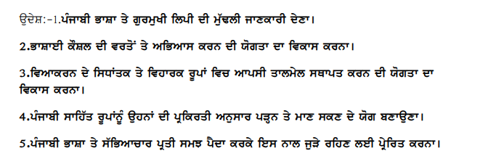

**Hindi Shikshan**

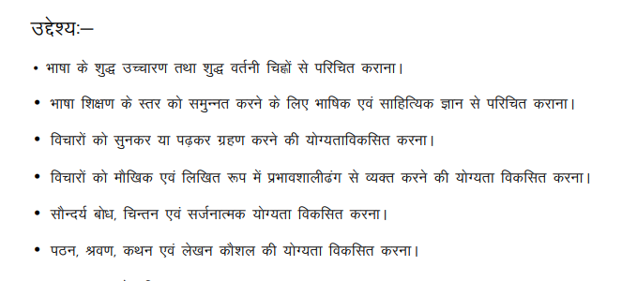

**Diversity, Gender and Inclusive Education**

1. To understand the present approach on education of children with special needs
2. Instead of blaming an individual for his/her failure, the need is to understand how barriers to learning arise from various discriminatory practices, curriculum, teaching approaches, school organization, and various other social and cultural factors
3. To focus on the structures (implicit and explicit) in our schools that serves as a hindrance to the inclusion of all students
4. To explore and understand the possibility of change through inclusive education
5. To develop a comprehensive and critical understanding on disability, marginalization and inclusive education.

**Children’s Physical and Emotional Health and Yoga Education –II**

1. To draw out and work with different faculties simultaneously i.e. physical, intuitive, emotional, sensual and mental through practical exercises.
2. Build imagination and concentration of the body and mind. Structured exercises for coordinating, enhancing and translating imagination into physical expression.
3. Learn to challenge and shift one s own attitude and standpoint as one learns to understand multiple perspectives to empathise.

**Creative Drama, Fine Arts and Education**

1. Identify and develop one s own creative potential.
2. Bring the arts into the centre of exploration, e.g. in visual arts: semiotics of the image/film/play/music; how is an image to be made meaning of; how can an image act as a starting point for an exploration.
3. Recognize the role of creative drama, Fine Arts as education in the elementary school
4. Learn to identify areas that are best suited for drama exploration
5. Examine through chosen themes, how learning can take place in the classroom through group drama exploration by a whole class of elementary school students
6. Explore the role of the teacher as creative guide in learning that is drama driven

**Towards Self-understanding and Evolving an Educational Vision**

1. To make student-teachers aware of some key shaping factors in their lives
2. To enable an exploration of one significant event or experience
3. To share and learn from each other’s experiences

**School Internship**

**Year I & Year II Specific Objectives (First Phase For 15 days in each year)**

1. To observe children and the teaching learning process in a systematic manner.
2. To learn to relate to and communicate with children.
3. To evaluate school textbooks and other resource material critically in the context of childrens development and pedagogic approach used.
4. To develop a repertoire of resources which can be used by the intern later in her teaching - textbooks, children s literature, activities and games, excursions
5. To reflect critically on practice by visiting a learning centre

**Specific Objectives (Second Phase For 45 days in each year)**

1. To experience the school in its totality; activities in addition to classroom teaching include school activities and interaction with parents.
2. To assume the role of a regular teacher with appropriate planning taking into account the diverse needs of students and the varying contexts that impact the teaching learning process.
3. To be able to innovate within existing systemic limitations.
4. To learn to conduct meaningful classroom activities by careful selection and organization of such activities.
5. To critically reflect on her own school experiences and keep records of the same.
6. To learn to assess different aspects of children s learning without a focus only on achievement